

**Project Proposal:**

LABVIEW-Simulated Elevator (Three Floors)

By:

Course: EECE 200

Monday, November 28, 2011

**Problem Statement:**

In the shadow of the constant evolution of constructions and the ever-evolving phenomenon of skyscrapers, modern buildings have been constantly towering higher and higher with the will to fit more families and individuals. Ten, fifty, and even hundred floor buildings have been successfully constructed, which raises a question: How will the residents (of all types: too old, too young unhealthy…) be able to “climb” to their apartments? Well the answer is the use of elevators of course. As simple as this answer might seem, its complexity of building and programming overwhelms its simplicity in saying. In short, a three floor elevator project simulated by LABVIEW would represent a resemblance to all elevators that we rely on each day, which are problem-solvers for mankind. It’s time to find out the complex language that the elevator speaks to itself as a result of a simple push of a button.

**Project Objectives:**

* **Curricular Objectives:**

1. Designing a fully-functional elevator.
2. Controlling the following in the designed elevator:
   1. The doors: They must open automatically by the application of motion sensors.
   2. The motor: It must respond correctly to the desired motion of the elevator, according to the floor where the “CALL” button was pressed. That is, the motor must have the ability to rotate in both ways.
   3. The fan: It must operate automatically when needed, by applying heat sensors.
3. Creating a suitable LABVIEW VI to control the designed elevator through SPEEDY.
4. Linking the VI and the elevator and testing them to ensure functionality.

* **Extracurricular Objectives:**

1. Learning the value of teamwork in the workplace and the necessity to trust others as individuals to get their part done, and not to disappoint them by getting your recommended part done as well.
2. Learning to be independent and not to be spoon-fed or take everything for granted: Obviously, this project is no simple one, and not all steps will be taught in the given courses, which pushes the group to do some researching and trial-and-error experiments to discover the right methods by themselves.
3. Simply having fun and feeling the pleasure of being an engineer! It might not seem professional to say this but it has to be said nonetheless: The real pleasure of engineering is not memorizing solid formulas and dealing with resulting numbers, the pleasure of engineering lies in building a project with your bare hands and staying up late to make it work properly.

**Specifications:**

1. Inputs:
   1. A motion sensor digital input installed on the door of the elevator to detect motion and open.
   2. A temperature sensor installed in the elevator to detect increase in temperature and turn on the fan.
   3. One digital input per floor to determine the position of the elevator cabin.
   4. One digital input per floor to act as the “CALL” button.
   5. An analog audio input from inside the elevator allowing it to move according to the order given from inside the cabin.
2. Outputs:
   1. A digital output that turns the motor of the elevator on and off.
   2. A digital output to turn the ventilation system (fan) on and off.
   3. Two digital outputs to display the floor number the elevator is currently on.
   4. One digital output per floor to open and close the elevator doors.
   5. One digital output which controls the direction of rotation of the motor (lifting the elevator up or down)

**Project Constraints:**

1. Only one SPEEDY is allowed per group which makes it a challenge to fit all the needed inputs and outputs on such a limited board.
2. It is not allowed to borrow the SPEEDY but required to work with it during university and that is an obstacle.
3. All the wires and connections must be well hidden to seem like a realistic design.

**Report Organization:**

Table of Contents

**Grading Sheet1**

**Title Page2**

**Introduction**

Problem Statement**2**

Project Objectives

Curricular Objectives**3**

Extracurricular Objectives**4**

**Specifications**

Inputs**4**

Outputs**5**

**Constraints5**

**Report Organization6**

**Methodology**

Brainstorming

Methods**7**

Results**9**

Alternative Design**10**

**Schedule11**

**Cost Summary12**

**Expected Results12**

**Members’ Qualifications12**

**References13**

**Brainstorming:**

Methods:

As for software and logic, we have come up with the following:

* + - * Sub-VI’s will be heavily implemented due to the large scale of the project.
      * Case structured will be used to control the state of lamps.

**Elevator Design Sketch:**



"Elevator Design and Control Simulation Using LabVIEW (2003)." *Scribd*. Web. 27 Nov. 2011. doc/7072695/Elevator-Design-and-Control-Simulation-Using-LabVIEW-2003>.

**LABVIEW Program:**

**System Block Diagram:**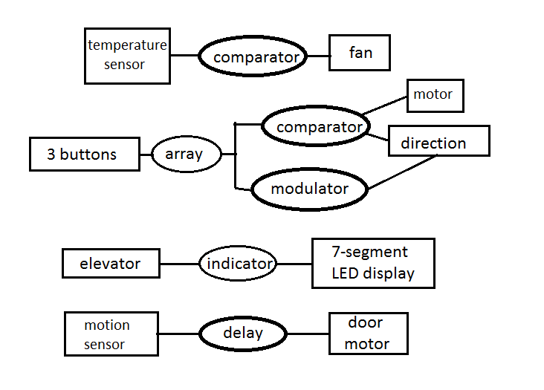

**Alternative Design:**

As for an alternative design, we have discuused a different model where the motor of the elevator is external, i.e. placed outside of the cabinet, like the ones in real-life. However, this motor should be larger than the one used when installed in the cabinet, since the farther the elevator is from its motor the more force needed to be exerted by the motor to move it. In this design, SPEEDY may be hidden at the base of the elevator.

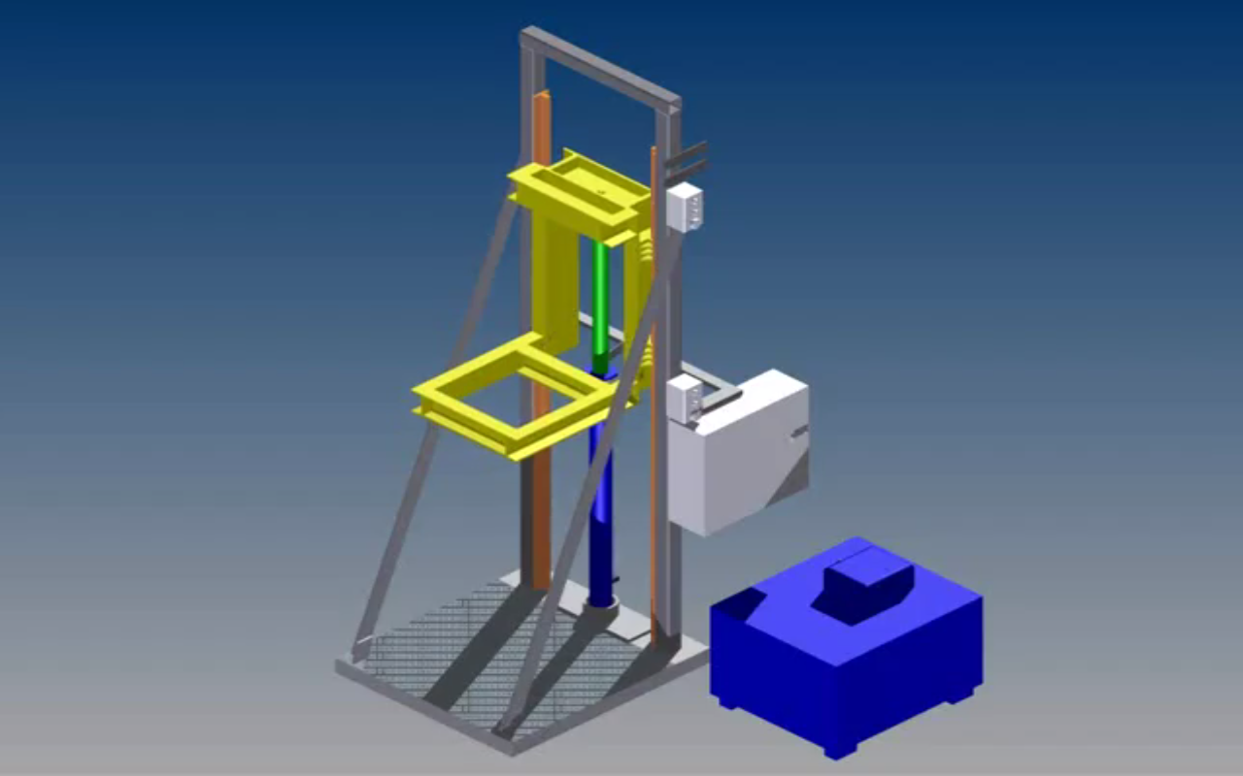

Base of elevator, SPEEDY may be hidden there

Iron/Steel wire

External Motor

**Schedule:**

|  |  |  |
| --- | --- | --- |
| Target | Date of Application | Deadline |
| Group Forming and Naming | November 15 | November 21 |
| Proposal Report | November 22,23,24 | November 28 |
| Project Soft Demonstration | December 5,6,7,12,13 | December 16 |
| Project Software and Hardware | January 4,5,6 | January 11 |
| Project Presentation and Demo | January 11 | January 12,13 |
| Project Final Report and Log Book | January 25,26 | January 28 |

**Cost Summary:**

|  |  |  |  |
| --- | --- | --- | --- |
| Item | Quantity | Price ($) | Total Price ($) |
| SPEEDY-33 | 1 | 600 | 600 |
| Plexiglass Model | 1 | 250 | 250 |
| Wooden Model | 1 | 25 | 25 |
| Motor | 2 | 3 | 6 |
| Temperature Sensor | 2 | 2 | 4 |
| Fan | 2 | 2 | 4 |
| Bump Sensor | 5 | 0.5 | 2.5 |
| Motion Sensor | 5 | 1 | 5 |
| LED | 10 | 0.5 | 5 |
| Aesthetics | - | 15 | 15 |
| Switch | 10 | 0.5 | 5 |
| Seven Segment Display | 3 | 0.5 | 1.5 |
| Total | 41 | 300 | 923 |

The total cost of the project was found to be 923$.

**Expected Results:**

The designed elevator is anticipated to be a miniature copy of a real-life elevator; responding with accuracy and sequence to every order and every call. Its power consumption should be low yet reasonable, and its sturdiness should be similar to that of a normal elevator, capable to withstand the same ratio of its mass over the mass inside its cabin.

**Members’ Qualifications:**

**XXXXXXXXXX**: Previous school project experiences, critical thinking skills

**XXXXXXXXXX**: Construction background, programming background

**XXXXXXX**: English Skills, electrical background

**XXXXXXXXX**: Logistic management skills, critical thinking skills

All team members will participate in every aspect of the project, but according to the type of skill exhibited there would be a leader for each phase.

**References:**

1. B.Neblu: “Project Proposal Writing” (E-Book)
2. Scribd: <http://www.scribd.com/doc/7072695/Elevator-Design-and-Control-Simulation-Using-LabVIEW-2003>
3. YouTube: <http://www.youtube.com/watch?v=TWlv4MU0vwg>